

Pressure Transducers

[Document subtitle]



[Date]

Blue Origin, LLC.

[Company address]

Contents

# What are they?

Pressure transducers are devices that are deiced to measure the pressure of a fluid and convert that measurement into an electrical signal.

# Types of PTs and how they work

## Piezoresistive strain gauge

These PTs utilize strain gauges bonded to a flexible diagram. This allows small strains caused by pressure changes to deform the diaphragm material, modifying the resistance of the strain gauges. These gauges, often arranged as part of a Wheatstone bridge, provide the measurement as an electrical signal.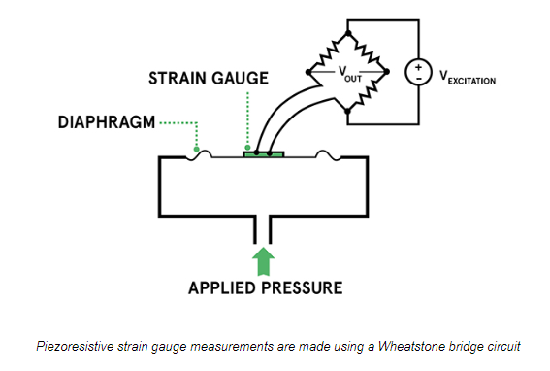

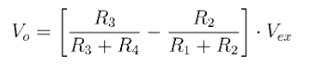

Note that this is an active circuit that requires an excitation voltage to be applied across the bridge. A change in pressure leads to a change in the resistance of the strain gauge, leading to a change in output voltage. The bridge is normally balanced such that with ambient pressure on the strain gauge, the output voltage is 0. Any deterioration or damage to the gauge or any of the resistors can lead to inaccurate measurements. Additionally, these sensors are susceptible to other factors that can impede their accuracy. Electronic noise can disrupt the excitation signal, affecting the resulting output. Thermal agitation can drift the accuracy as well since the temperature coefficient for the bridge resistors could vary from the strain gauge. Together, these considerations need to be made when selecting a piezoresistive transducer.

## Capacitive

Capacitive censors display a capacitance change as at least one plate of a the two parallel plates of a capacitor deflects under applied pressure. These sensors can be highly sensitive and measure pressures below 10mbar while withstanding large overloads. A major trade-off in these sensors is with capacitor size. Large capacitors are capable of generating larger signals, smaller signals have the benefit of increased frequency range, sensitivity and response time. Diaphragm thickness can also be tuned to control the pressure ranges at which the sensor can operate, where thicker diaphragms allow for higher pressures.

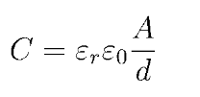

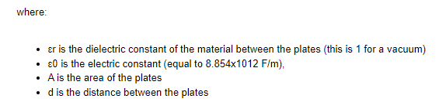

## Piezoelectric

These sensors use piezoelectric crystals to convert pressure inputs to electrical signals. A piezoelectric material is simply one that generates a charge when it bends (a pressure is applied). Moreover, the generated charge contains both magnitude and phase, indicating both force and polarity (direction). These are best used for high-frequency pressures, typically in ultrasound systems.

## Semiconductor strain gauges (MEMS)

These sensors contain a piezoresistive or capacitive pressure-sensing mechanism fabricated on silicon. Signal conditioning electronics can be co-packaged into the silicon to provide filtering, amplification and digitization of the signal. Doping of the silicon material can tune the sensors properties. These sensors are very low power and are great choices for any small-battery powered systems. Additionally, the ability to use either resistive or capacitive sensing allows for them to be used in a wide breadth of applications. Capacitive sensors have low power consumption, good sensitivity and temperature independence, whereas resistive sensors are highly linear and stable.

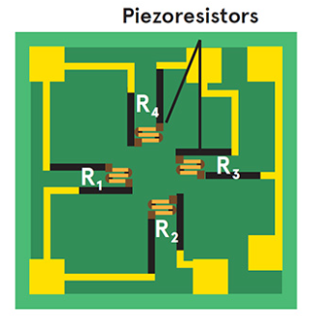

# Output signals:

Pressure sensors can work as both transducers (voltage output) or transmitters (current output). The major difference here is that voltage outputs require less power consumption, but current outputs have lower noise susceptibility and allows for significantly longer cabling.

# Types of Measurements

Depending on the configuration of the diaphragm and pressure sensing element, the output signal will represent a different measurement. These measurements are gauge, absolute and differential.

## Gauge

In gauge measurement, one side of the diaphragm is exposed to the pressurized environment that is being measured, whereas the other side is open to the ambient environment, typically atmosphere. Therefore, a value of 0 occurs when the measured environment is equal to the ambient.

## Absolute

In absolute measurement, only a single side of the diaphragm is subject to a pressurized environment (the other side is held in vacuum. This means that a measurement of 0 only occurs when the exposed side is also in vacuum.

## Differential

In differential measurement, both ports to the diaphragm are exposed to the environment. Thus 0 occurs when both ports are under the same pressure.

# How we use pressure sensors

## Models

## Wiring

## Sampling

## Scaling

## Console

In console, PT’s are represented as float numerics.

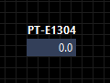

These values are constantly sampled, with the value being routed to both STM servers (mission and admin). This value can be read from the STM server and displayed as shown above. 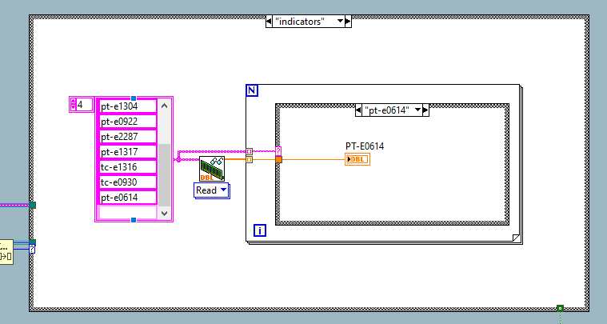

Figure How console loops through the STM to read and display the values of many sensors on the DAQ

Alternatively, a sensor can be read independently of the main ‘indicator’ loop by using the method below.

